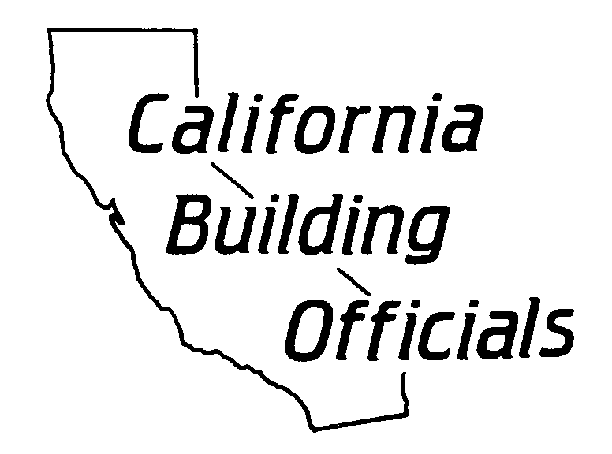**CALBO Access Committee**

**_______________________________________________**

***Your CALBO Access Committee is Hard at Work***

Good Day CALBO Member;

The CALBO Access Committee (CAC) would like to bring to your attention that DSA revised the following access compliance reference materials to include the 2013 Intervening Code Adoption Cycle Supplement posted on May 5, 2015, published on January 1, 2015, effective July 1, 2015:

* 2010 - 2013 California Building Code (CBC) Cross Reference Matrix
* 2013 CBC Expanded Table of Contents for Chapter 11B
* 2013 CBC Advisory Manual

These documents are located on [DSA’s California Access Compliance Reference Materials Web Page](http://dgslistsrv.ca.gov/t/347135/1432974/1489/0/?u=aHR0cDovL3d3dy5kZ3MuY2EuZ292L2RzYS9Qcm9ncmFtcy9wcm9nQWNjZXNzL2FjY2Vzc21hbnVhbC5hc3B4&x=a032330a).

Additionally the DSA **Access Code Update Stakeholder Forums**

Division of the State Architect   
1102 Q Street, 5th Floor   
Sacramento, CA 95811

Meetings will take place from 9:00 a.m. to 4:00 p.m. on the following dates:

* May 12, 2015
* May 21, 2015
* June 23, 2015
* July 14, 2015

A CAC representative will be present at all meetings supporting CALBO.

Thank you for your support and we look forward to working with you,

Sincerely,

signature 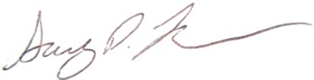 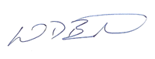

Jeff Janes Gary Layman Mike Brinkman

CALBO Board Member City of Oroville City of Newman / CSG

Access Committee Liaison Access Committee Chair Access Committee Vice Chair