**CALBO**

**ACCESS COMMITTEE**

**Swimming Pool/Spa Checklist**

**SCOPING and INSPECTIONS**

**2013 California Building Code**

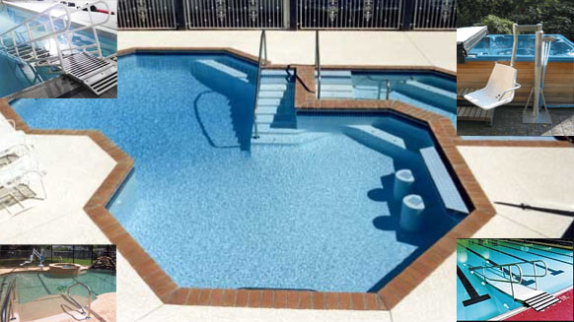

In determining which pool entry type is required the following steps should be applied when designing or reviewing to the 2013 CBC:

Determine the type and size of pool which is proposed to be installed.

Refer to the 2013 CBC 11B-242.2 for required type of entry by using the general requirements as shown below in the means of pool entry table.

Refer to the 2013 CBC 11B-1009 for the requirements of the type of entry proposed.

Accessible routes, accessible parking, pool decks, restrooms and all accessible elements shall comply with applicable requirements.

**11B-242.2 Swimming Pools.** At least two accessible means of entry shall be provided for swimming pools…At least one accessible means of entry provided shall comply with 11B-1009.2 (Pool Lifts) or 11B-1009.3 (Sloped Entries).

*Where a swimming pool has less than 300 linear feet of swimming pool wall, no more than one accessible means of entry shall be required provided that the accessible means of entry is a swimming pool lift complying with 11B-1009.2 (Pool Lifts) or sloped entry complying with 11B-1009.3 (Sloped Entries).*

*Wave action pools, leisure rivers, sand bottom pools, and other pools where user access is limited to one area shall not be required to provide more than one accessible means of entry and catch pools shall not be required to provide an accessible means of entry provided that the catch pool edge is on an accessible route.*

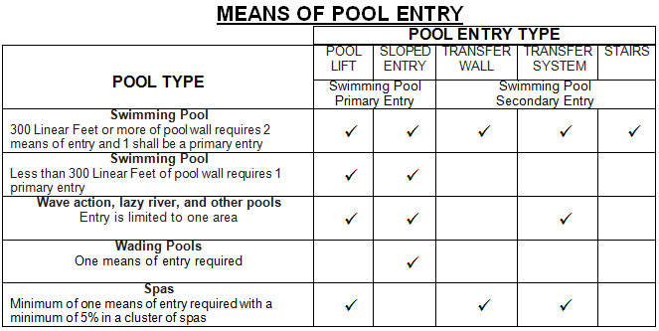

* 11B-242.2 Is there more than 300’ linear feet of swimming pool wall? _____________________________
  + If yes, are two accessible means of entry provided? ___________________________________________
  + If no, is one accessible means of entry provided? _____________________________________________
* Is one accessible means of entry provided for spas? ___________________________________________
  + If spas clustered, Is no less than one or 5% accessible? _______________________________________

**Inspection Checklist for Pool Lifts**

* + 11B-1009.2 Is a pool lift provided for entry? _____________________________________________________
  + 11B-1009.2.1 Is lift located where water level is 36” min and 48” max except for spas? ___________________
  + 11B-1009.2.2 Is the centerline of the seat located 16” min. from the edge of the pool? ____________________
  + Is the deck surface between the centerline of the seat and the edge of the pool level (1:48)? ______________

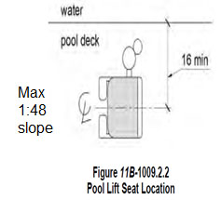 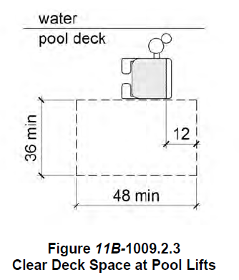

* + 11B-1009.2.3 Is there a 36”X48” clear, level deck space next to the seat opposite the water for transfer? _____
  + Does the clear deck space extend 48” from a line 12” behind the rear edge of the seat? __________________
  + Is the clear deck space level (1:48)? __________________________________________________________
  + 11B-1009.2.4 Is the seat rigid and does it have a back support at least 12” tall? _________________________
  + Does the seat stop at 17”min-19”max above deck to top of seat? ____________________________________
  + Does the seat have an occupant restraint that is compliant with 11B-309 Operable Parts? ________________
  + 11B-1009.2.5 Is the seat 16” wide minimum? ____________________________________________________
* 11B-1009.2.6 Is the seat provided with footrest and two armrests? *Footrest not required in spas? __________*
  + Does the armrest opposite the water fold clear of the seat or is it removable? __________________________
  + 11B-1009.2.7 Is the lift capable of unassisted operation from both the deck and water level? ______________
    - Are the controls and operating mechanisms operable with one hand, not require tight grasping, pinching, or twisting of the wrist with the force required to activate *operable parts 5 pounds maximum? ________________*
  + Is the lift stable with no unintended movement while a person is getting into or out of the seat? _____________
* 11B-1009.2.8 Will the lift submerge to a water depth of 18” minimum below stationary water level? _________
* 11B-1009.2.9 Does the lift have a weight capacity of 300 lb. minimum? _______________________________

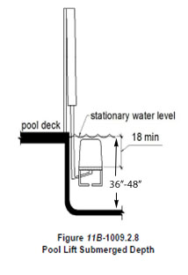

**Inspection Checklist for Sloped Entry**

* 11B-1009.3 Is there a sloped entry? ___________________________________________________________
  + If spas clustered, is 5% and no fewer than one entry provided? _____________________________________
* 11B-1009.3.1 Is the sloped entry 8.33% maximum slope? __________________________________________
  + 11B-1009.3.2 Does the sloped entry extend to a depth of 24”-30” below the stationary water level? _________
  + Does the sloped entry extend to a depth of 24”-30” below the stationary water level (1:48) maximum slope and 72” minimum long at the bottom of the ramp? ___________________________________________________
  + 11B-1009.3.3Is there at least two handrails with a 33” – 38” clear width? ______________________________

*Handrails are not required in wading pools and Handrail extensions are not required at the bottom landing.*

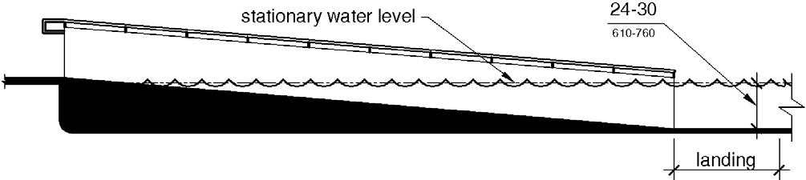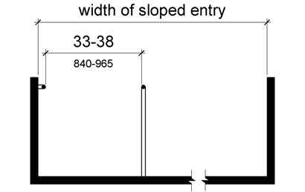

**Inspection Checklist for Pool Transfer Walls**

* + 11B-1009.4.1 Is a transfer wall provided? ____________________________________________________
  + Is there a 60” X 60” minimum clear deck space in front of the transfer wall? _________________________
  + Is the maximum slope of the deck space 1:48” maximum slope? __________________________________
  + If only one grab bar is provided, is it centered in the clear deck space? _____________________________
  + If two grab bars are provided, is the clear deck space centered between the grab bars? _______________
  + 11B-1009.4.2 Is the height of the transfer wall 16” minimum -19” maximum above the pool deck? ________

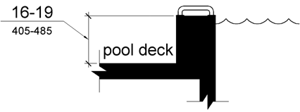 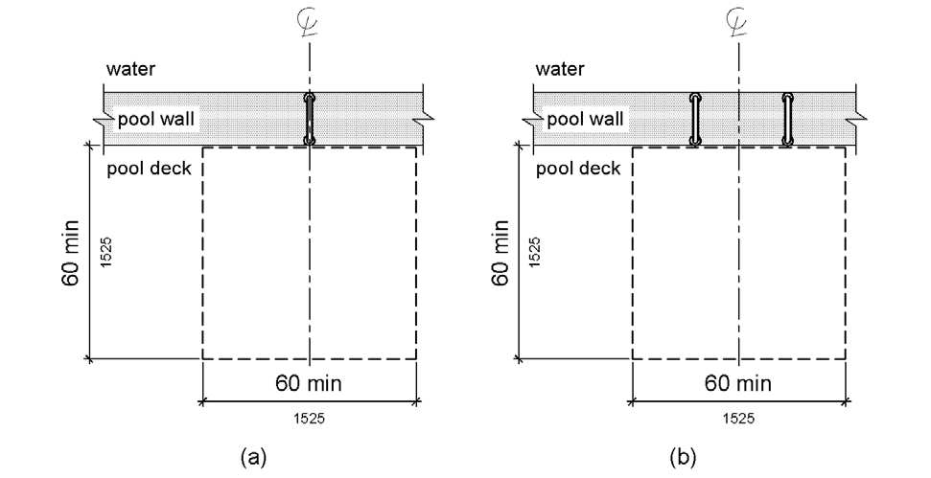

* + 11B-1009.4.3 Is the depth of the transfer wall 12” minimum and 16” maximum? ___________
  + Is the length of the transfer wall 60” minimum and centered on the clear deck space? ____________
  + Are the surfaces of transfer walls not sharp and have rounded edges? _____________________________

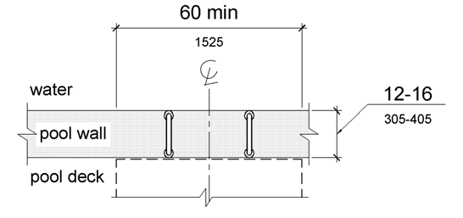

**Inspection Checklist for Grab Bars on Pool Transfer Walls**

* 11B-1009.4.5 Does at least one grab bar have circular cross sections with an outside diameter of 1¼” minimum and 2” maximum provided on the transfer wall? ____________________________
* Are Grab bars perpendicular to the pool wall and extend the full depth of the transfer wall? _____________
* Is the top of the gripping surface 4” minimum and 6” maximum above transfer walls? _______
* Where one grab bar is provided, is the clearance 24” minimum on both sides of the grab bar? _____
* Where two grab bars are provided, is the clearance between grab bars 24” minimum? ___________
* Grab bars on transfer walls shall not be required to be 34”-38” high. _______________________________

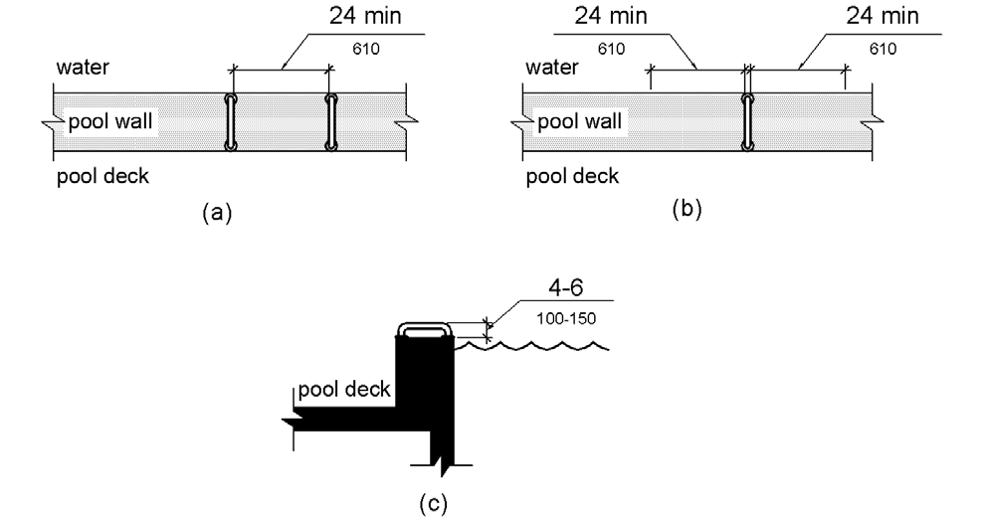

* 11B-1009.5.1 Is a transfer platform provided at the head of each transfer system? ______________________
* Are the transfer platforms 19” minimum clear depth and 24” minimum clear width? ____________

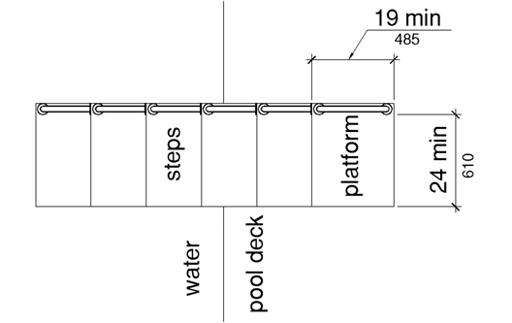

**Inspection Checklist for Platforms on Pool Transfer Walls**

* 1009.5.2 Is a transfer space of 60” minimum by 60” minimum with a slope not steeper than 1:48 provided at the base of the transfer platform surface and centered along a 24” minimum side of the transfer platform? ________________________________________________________________________________
* Is the side of the transfer platform serving the transfer space unobstructed? ___________________________

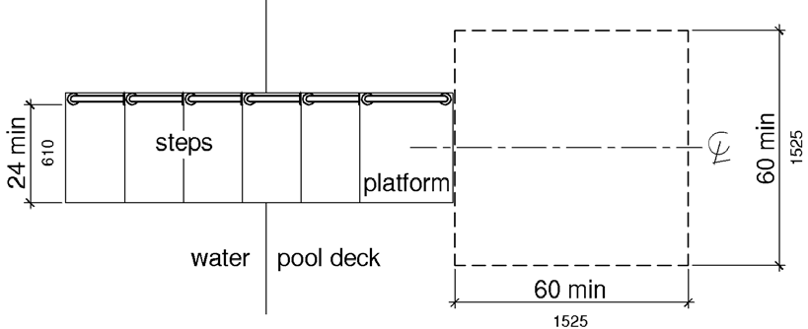

* 11B-1009.5.3 Is the height of the transfer platform 16” minimum -19” maximum above the pool deck? ____
* 11B-1009.5.4 Is the transfer step height 8” maximum? ____________________________________
* Does the surface of the bottom tread extend to a water depth of 18” minimum below the stationary water level? ___________________________________________________________________________
* 11B-1009.5.5 Does the surface of the transfer system have smooth rounded edges? _________________

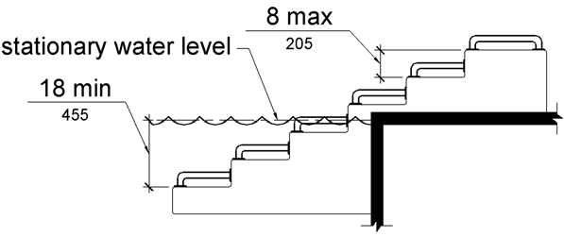

**Inspection Checklist for Steps on Pool Transfer Systems**

* 11B-1009.5.6 Does each transfer step have a tread clear depth of 14” minimum and 17” maximum and with a tread clear width of 24” minimum? ___________________________________

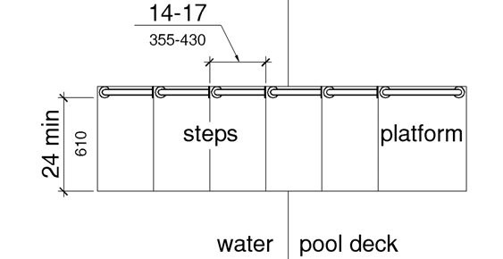

* 11B-1009.5.7 Is at least one grab bar on each transfer step and the transfer platform or a continuous grab bar serving each transfer step and the transfer platform provided? ________________________________
* Where a grab bar is provided on each step, are the tops of gripping surfaces 4” minimum and 6” maximum above each step and transfer platform? _______________________________________
* Where a continuous grab bar is provided, is the top of the gripping surface 4” minimum and 6” maximum above the step nosing and transfer platform? ________________________________________
* Do grab bars have circular cross sections with an outside diameter of 1¼” minimum and 2” maximum and located on at least one side of the transfer system? ________________________________
* Does the grab bar located at the transfer platform allow an obstructed transfer? _____________________

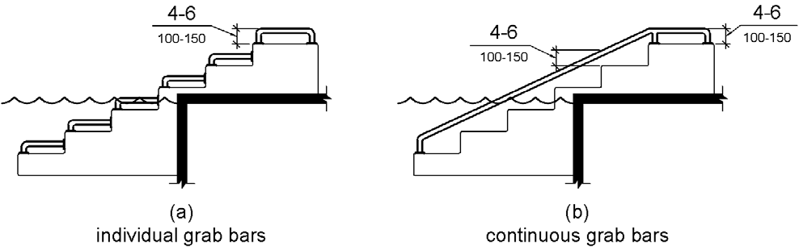

* 11B-1009.6.1 Are the pool stair tread runs 11” minimum in length? ___________________________________
* EXCEPTION: Pool step riser heights shall not be required to be 4” high minimum and 7” high maximum provided that riser heights are uniform. ________________________________________________
* 11B-1009.6.2 Is the width between handrails shall be 20” minimum and 24” maximum? ________
* Are the handrails 34”-38” above the nose of the treads? ___________________________________________

**Note handrail extensions shall not be required on pool stairs.**

**Inspection Checklist for Pool Fences**

* CBC 3119B is the pool provided with a pool enclosure? ___________________________________________
* CBC 3119B Is it enclosed by one or a combination of the following: a fence, portion of a building, wall, or other approved durable enclosure? ________________________________________________________________
* Is the enclosure a minimum effective perpendicular height of 5’ as measured from the outside as depicted in Figure 31B-4? ____________________________________________________________________________
* Are the openings, holes or gaps in the enclosure, doors and/or gates designed not to allow the passage of a 4” diameter sphere? _________________________________________________________________________
* Is the enclosure designed and constructed so that it cannot be readily climbed by small children? __________
* Is the enclosure free from horizontal and diagonal member designs which might serve as a ladder for small children? ________________________________________________________________________________
* Are horizontal members shall be spaced at least 48” apart? ________________________________________
* Are planters or other structures that can be climbed a minimum of 5‘of the outside of the pool enclosure or outside of a 5‘arc as depicted in Figure 31B-5? __________________________________________________

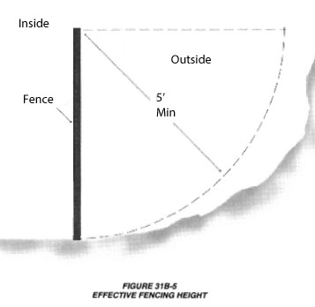 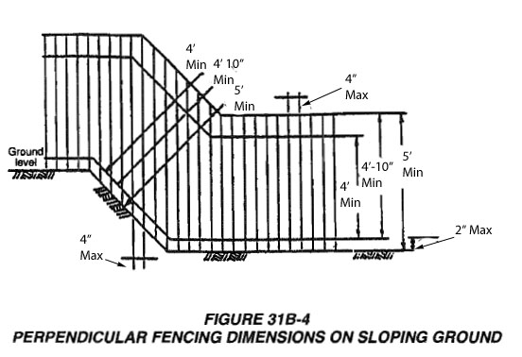

* If chai link is used, are the openings not greater than 3/4" measured horizontally?__________________

**CBC 3119B.2 If gates and doors opening into the pool enclosure also shall meet the following specifications:**

* Are the gates and doors equipped with self-closing and self-latching devices operable without twisting or pinching? ________________________________________________________________________________
* Does the self-latching device keep the gate or door securely closed? _________________________________
* Gates and doors open outwardly away from the pool except where otherwise prohibited by law? ___________
* Hand activated door or gate opening hardware shall be located at a height no lower than 42” but no higher than 44” above the deck or walkway? __________________________________________________________
* Are the gates and doors capable of being locked during times when the pool is closed? __________________
* Does the pool enclosure have at least one means of egress without a key for emergency purposes? ________
* Do the gates have a sign in letters at least 4” high stating EMERGENCY EXIT”? ________________________
* Is the enclosure constructed so that all persons will be required to pass through common pool enclosure gates or doors in order to gain access to the pool area? ________________________________________________
* Do all gates and doors exiting the pool area open into a public area or a walk-way? _____________________

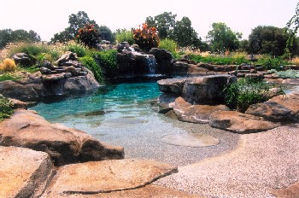

This checklist has been developed by the CALBO ACCESS COMMITTEE (CAC) for use as guide line tool in plan design plan reviews and inspections for swimming pools, spas, wading pools, water resorts and all public pool or swimming type facilities.

Please note that this checklist is for reference only and based off the code sections and figures from the 2010 ADA Standards and the 2013 California Building Code.

CAC strives for a better built environment by providing accessibility awareness through trainings, brochures and public outreach.

Sincerely,

signature 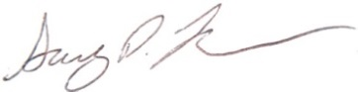 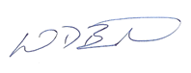

Jeff Janes Gary Layman Mike Brinkman

CALBO Board Member City of Oroville City of Newman / CSG

CAC Liaison CAC Chair CAC Vice Chair