The California Advanced Lighting Controls
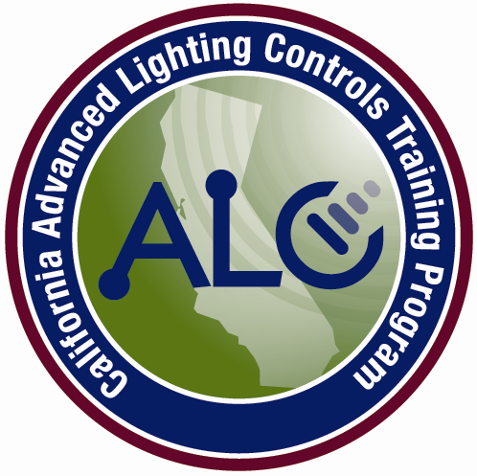
Training Program
CALCTP

Date: June 25, 2014

ATTENTION: BUILDING DEPARTMENTS

Re: 2013 ENERGY STANDARDS: Certification Requirement For Nonresidential Lighting Controls Acceptance Test Technicians is Now Mandatory

This announcement provides notice that Nonresidential Lighting Control Acceptance Tests under the 2013 California Building Energy Efficiency Standards (“2013 Energy Code”) are now required to be performed by Certified Lighting Controls Acceptance Test Technicians. Section 130.4, subdivision (c) of the 2013 Energy Code requires lighting control acceptance tests to be performed by trained and Certified Lighting Controls Acceptance Test Technicians. However, this requirement was contingent on the California Energy Commission first making an “Industry Certification Threshold” determination to ensure there was sufficient availability of Certified Lighting Control Acceptance Test Technicians prior to making the use of certified Technicians mandatory.

At its June 18, 2014 business meeting, the Commission formally determined that the Industry Certification Threshold has been met for Lighting Control Acceptance Test Technicians. Accordingly, the requirement to use Certified Lighting Control Acceptance Test Technicians is mandatory as of the July 1, 2014 effective date of the 2013 Energy Code.

The lighting control acceptance tests that now require the use of certified technicians are the tests set forth in the following Acceptance Test Forms:

NRCA-LTI-02-A – Lighting Controls

NRCA-LTI-03-A – Automatic Daylighting

NRCA-LTI-04-A – Demand Responsive Controls

NRCA-LTO-02-A – Outdoor Motion Sensor and Lighting Shut-off Controls

All new construction and additions, and any retrofits impacting more than 10 percent of the lights, must install lighting controls and those controls must be acceptance tested by a state certified lighting controls acceptance test technician. Building departments may not provide a certificate of occupancy for nonresidential construction projects subject to the 2013 Energy Code unless the department confirms that lighting control acceptance tests have been performed and approved by State Certified Acceptance Test Technicians.

Confirmation is provided by verifying that a valid Certified Lighting Control Acceptance Test Technician certification identification number issued by an approved Acceptance Test Technician Certification Provider has been included on the Acceptance Form.

The California Advanced Lighting Controls Training Program (“CALCTP”) is the only Acceptance Test Technician Certification Provider currently approved by the Commission to certify lighting control acceptance test technicians.

CALCTP certification identification numbers can be verified by going to the CALCPT website and entering the number. The link for number verification is: https://www.calctp.org/acceptance-technicians.

In addition, if project applicants or contractors are looking for a Certified Lighting Control Acceptance Test Technician, CALCTP maintains a list of available technician employers by county. This can be accessed at: https://www.calctp.org/acceptance-technicians/contractors.

Please note that this notice only applies to the required use of certified Lighting Control Acceptance Test Technicians.

Any questions or complaints regarding CALCTP Certified Lighting Control Acceptance Test Technicians should be directed to CALCTP either by calling the toll-free number (877) 670-7910, or by sending an email to info@calctp.org.

Cal. Code Regs., tit. 24, Part 6, § 130.4 (c).
The Industry Certification Threshold provides that the requirement to use certified Lighting Control Acceptance Test Technicians does not become effective until the Commission determines that at least 300 technicians are certified and a reasonable path for certification is available for the majority of certain specified industry professionals. Cal. Code Regs., tit. 24, Part 1, § 10-103-A (b).
Per the Commission regulations, CALCTP has “interim” approval to certify Lighting Control Acceptance Test Technicians, pending formal approval of CALCTP’s application. The Commission may approve additional providers in the future. If a technician indicates that he has been approved by a provider other than CALCTP, the building official should contact the Commission to confirm that the provider has been approved.
The 2013 Code also requires HVAC acceptance tests to be performed by trained and certified Mechanical Acceptance Test Technicians subject to the Industry Certification Thresholds being met. Cal. Code Regs., tit. 24, Part 6, § 120.5 (b). The Commission, however, has not yet made the Industry Certification Threshold finding for Certified Mechanical Acceptance Test Technicians. Questions regarding certification requirements for Mechanical Acceptance Test Technicians should be directed to the Commission.

